**CFCO RR/E Code Maintenance Analysis**

Executive Budget Fiscal Proposal Summary

New York State receives a 6% enhanced FMAP for costs associated with Community First Choice Option (CFCO) state plan services which include Personal Care, CDPAS, Home Health Aide, PERS and NEMT. These funds can be claimed for CFCO services delivered via fee-for-service or managed care. LDSS’s, MCOs and OPWDD are responsible for adding and maintaining CF and CO RR/E codes for Medicaid members as part of assessment and eligibility determination activities.

The CFCO 6% FMAP claiming process performed by Deloitte and the Division of Finance and Rate Setting (DFRS) relies on the CF/CO RR/E codes managed by LDSS, MCOs and OPWDD. A preliminary comparison of the 6% FMAP claimed between 2019 and 2021 indicates that FMAP was not claimed for up to approximately 128,700 likely CFCO eligible members in 2021 which represents approximately $211,331,040. This is an analysis of the Managed Care population identified by CF RR/E code for 6% FMAP claiming and does not include the fee-for service and OPWDD populations. It is suspected that there are multiple factors involved with the potential gap in claiming. The primary contributors are suspected to be:

* The inconsistent maintenance of CF RR/E Codes at the plan level.
* Delays in the performance of annual UAS-NY reassessments because of COVID-19 Public Health Emergency (PHE), which placed a referendum on the requirement to conduct bi-annual Community Health Assessments (CHAs).

Without accurate information pertaining to the CF RR/E code or NFLOC, members who should be eligible for 6% enhanced FMAP will simply be eliminated from the current claiming logic, executed every 6 months.

Propose to execute a pilot with DOH-selected MLTC Plans and DOH MLTC Plan Managers to accomplish the following regarding to improving the accuracy of CF RR/E Codes:

* Analyze current state plan responsibilities for CF RR/E Code maintenance.
* Develop a chase list of “likely CFCO eligible” members that currently do not have a CF RR/E Code assigned and work with plans to validate appropriate status of each member record.
* Analyze other issues related to the code maintenance processes.
* Develop solution options to ensure CFCO 6% FMAP is maximized including but not limited to:
  + Develop a Statewide RR/E Code Maintenance Plan and associated guidance based on the outcomes of the analysis.
  + Systems enhancements to remove plan and LDSS responsibilities for maintaining CF RR/E codes.

The purpose of this analysis is not to review or modify the CFCO service definitions that the DFRS and Deloitte claiming methodology utilizes; it is only intended to examine the CF RR/E codes that are inputs to the claiming process.

**CF RR/E Code Pilot Plan Timeline**

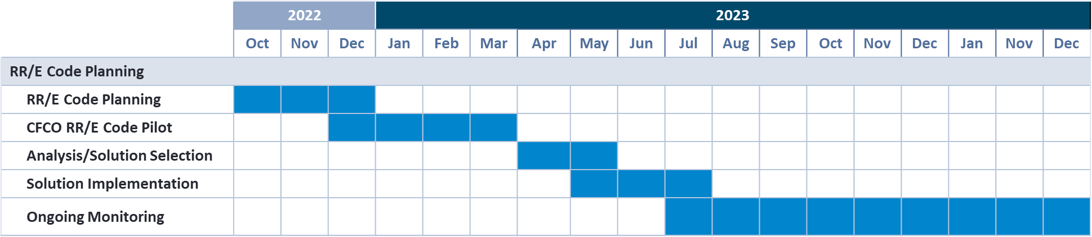

**Cost Savings Projections**

**Table 1: MCO Pilot Population and Cost Savings Projections**

|  |  |  |  |
| --- | --- | --- | --- |
| **Year** | **Count of MCO Members Missing a CF RR/E Code[1]** | **Total CFCO Service Cost For MCO Pilot Members[2]** | **Potential Additional 6% FMAP From Improving RR/E Code** |
| 2019 | 120,639 | $ 3,225,490,123 | $193,529,407 |
| 2020 | 118,347 | $3,045,028,911 | $182,701,735 |
| 2021 | 128,700 | $3,522,183,998 | $211,331,040 |

**Solution Options and Associated Costs**

All solution options include executing the CF RR/E Code Pilot to analyze the code maintenance process before implementing any changes.

**Table 2: CF RR/E Code Solution Options**

| **Solution** | **Considerations** | **Potential Costs** |
| --- | --- | --- |
| 1. Develop a Statewide RR/E Code Maintenance Plan and associated guidance based on the outcomes of the analysis | * Does not require any DOH systems changes * Aligns with current approved CFCO claiming methodology * Process remains dependent on MCOs following guidance and requires ongoing monitoring for compliance | * 1.5 NYSTEC FTE for execution |
| 1. Solution Option 1 plus a one-time update to CF RR/E Codes to update member records that are CF eligible but missing the code | * One-time update to RR/E codes will help state claim additional FMAP sooner than waiting for MCOs to update codes * Process remains dependent on MCOs following guidance requires ongoing monitoring for compliance | * 1.5 NYSTEC FTE for execution * ~397 hour LOE for similar updates on historical EP2118 |
| 1. Update DOH systems to determine members that are CFCO eligible for enhanced FMAP claiming without using codes maintained by plans or LDSS | * Will help state claim additional FMAP sooner than waiting for MCOs to update codes * Removes the need for MCOs and LDSS to maintain CF RR/E codes * A system-based solution removes the opportunity for missed claiming of eligible enhanced FMAP due to failure to follow manual process steps | * 1 NYSTEC FTE to support requirements definition * Further analysis needed to calculate full EP LOE |

**Additional Supporting Documentation**



1. Count is based on identifying CFCO eligible members based on eMedNY, MDW and UAS-NY CHA data who did not have an active CF or CO RR/E code in the calendar year.
2. CFCO service costs are based on actual utilization of CFCO services (Personal Care, CDPAS, Home Health Aide, PERS and NEMT) in the calendar year for individuals identified as potentially CFCO eligible